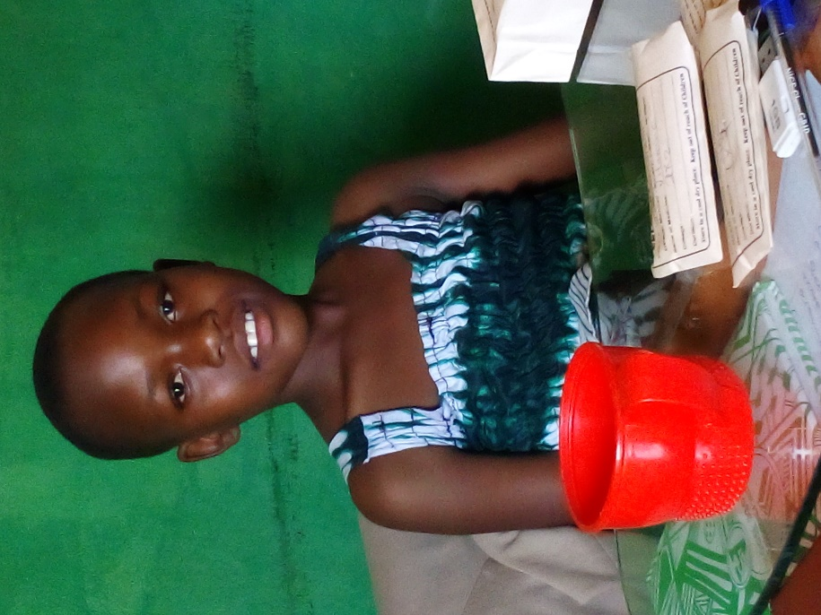

Figure 2 Akullu Hope Elizebeth

Age: 13 years

Figure 1 Akullo Tracy Patricia

Age: 12 years

Figure 3 Bua Brian Age: 7 years

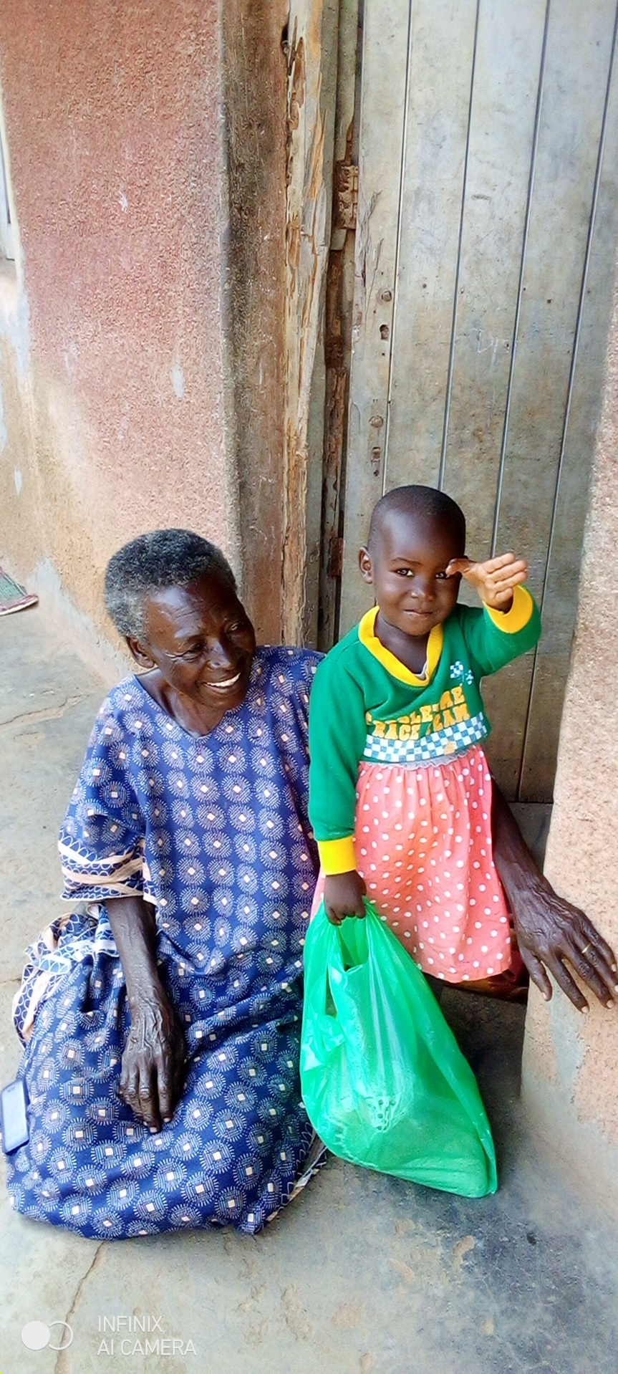

Figure 5: Akirapa Veronica Age: 13 Years

Figure 4: Laura

Age: 4 years